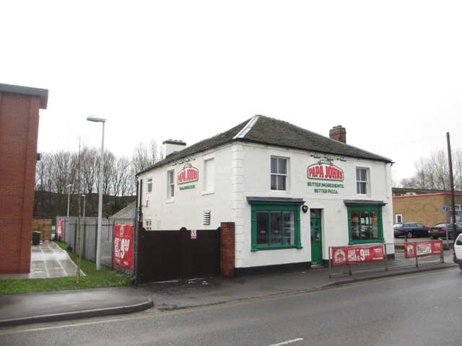
GET A “PIZZA”
THE ACTION

Investment properties on long term leases are hard to come by and FHP Property Consultants are pleased to offer a prominently located property let to Papa Johns.

Situated within a popular and retail and leisure destination on Etruria Road in Stoke on Trent, this detached property has been refurbished prior to operation as a pizza delivery business. The building is two storey and has enclosed yard to the rear sitting on a self-contained plot. The property is let to Papa Johns (GB) Limited for a term of 15 years without break.

Tim Richardson from FHP Property Consultants who are marketing the property comments:

“We are inviting offers in excess of £400,000, and due to the lot size expect this opportunity will prove extremely popular. The property lies in an excellent location next to Junction Leisure Park and opposite Octagon and Century Retails Parks so there are a wide range of complementary national operators in the vicinity including Odeon Cinema, 10 Pin Bowling, Mecca Bingo and Grosvenor Casino.”

Further information is available from FHP Property Consultants on 01332 224 857 or email Tim Richardson timr@fhp.co.uk.

Notes to Editors
- FHP is a Midlands based commercial property consultancy with offices in Nottingham and Derby. Its 80 strong team offers a full range of professional and commercial property solutions for clients in the retail, leisure, office, industrial, residential land and investment markets.

- The Company also provides businesses with a full property consultancy service including valuations, rates appeals, compulsory purchase advice with the Company having a strong Property Management Department which manages properties for individuals, corporate and institutions.

- FHP has been involved in some of the largest commercial property deals and developments within the region and works with national operators including Intu Properties Plc and Clowes Developments (UK) Limited.

- FHP is also able to call upon the expertise of its sister residential property Company FHP Living Limited which handles the sales of select properties across Nottinghamshire and the surrounding areas from boutique offices in the Nottingham City Centre and West Bridgford.

