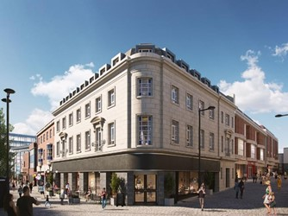
DEVELOPMENT OPPORTUNITY IN DERBY CITY CENTRE
The repurposing of older buildings has become an important part to the future of the High Street. As a result, we are pleased to bring to the market the upper floors of these former retail stores on the corner of Albion Street, Derby.

The property is arranged over the first and second floors, and benefits from a self-contained entrance at street level. The current owners are submitting a planning application for 8 apartments, with plans available upon request. The property is available on a long leasehold basis at a guide price of £300,000.

Dan Mooney of FHP Property Consultants commented:

“This is a fantastic development opportunity which is coming to market. City centre living is becoming increasingly popular and this property is in an ideal central location. In addition, the property benefits from a continual footfall given its busy spot, with the Derbion Shopping Centre one side and the Riverlights Bus Station on the other side. The property could suit local investors, but all interested parties are welcome to make enquires. If you are interested, please do not hesitate to get in touch.”

For further information or to arrange a viewing, please contact Dan Mooney (07929 716 330/dan.mooney@fhp.co.uk) or Darran Severn (07917 460 031/darran@fhp.co.uk).

ENDS

Dan Mooney

28 July 2021

